Database Management System – CS422 DE
Lab 4 – Week 9
-----------------------------------------------------------------------------------------------------------------
This Lab is based on Transact-SQL.
- Submit your own work on time. No credit will be given if the lab is submitted after the due date.
- Note that the completed lab should be submitted in .pdf format only.
---------------------------------------------------------------------------------------------------------------

Use the logical data model that you created in Lab 3 (The EasyDrive School of Motoring case study), create tables in your selected DBMS, and put some data into them (populate them).

PREPARE TABLE SQL IS AT LAST PAGE

- Create a View for the number of administrative staff located at each office.
ANS:
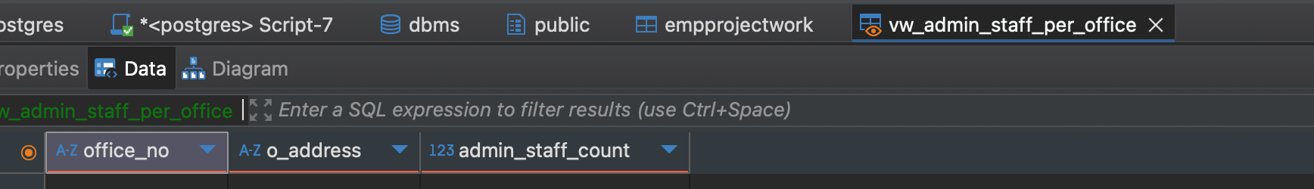
CREATE VIEW vw_admin_staff_per_office AS
SELECT
o.office_no,
o.o_address,
COUNT(s.staff_no) AS admin_staff_count
FROM office o
LEFT JOIN staff s
ON o.office_no = s.office_no
AND s.job_title = 'Admin'
GROUP BY o.office_no, o.o_address;

- Write a stored procedure that takes in one argument, the staff number of an instructor. The procedure outputs all details of all the lessons for that instructor.
ANS:
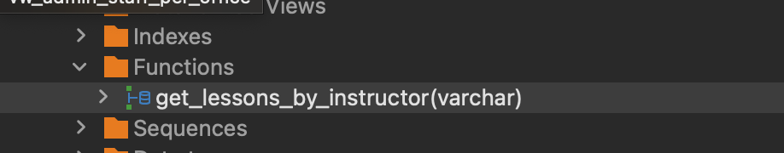
CREATE OR REPLACE PROCEDURE get_lessons_by_instructor(p_staff_no VARCHAR)
LANGUAGE plpgsql
AS $$
BEGIN
SELECT *
FROM lesson
WHERE staff_no = p_staff_no;
END;
$$;

- Create a trigger: In the Staff or Instructor table, add an attribute to keep track of the total number of clients that an instructor has. We will Not allow more than 20 clients per instructor. Add a trigger to Not allow a twenty-first client to be added.
ANS:

ALTER TABLE staff
ADD COLUMN total_clients INT DEFAULT 0;

CREATE OR REPLACE FUNCTION check_max_clients()
RETURNS TRIGGER AS $$
DECLARE
client_count INT;
BEGIN
SELECT COUNT(DISTINCT client_no)
INTO client_count
FROM lesson
WHERE staff_no = NEW.staff_no;

IF client_count >= 20 THEN
RAISE EXCEPTION 'Instructor already has 20 clients';
END IF;

UPDATE staff
SET total_clients = client_count + 1
WHERE staff_no = NEW.staff_no;

RETURN NEW;
END;
$$ LANGUAGE plpgsql;

CREATE TRIGGER trg_max_clients
BEFORE INSERT ON lesson
FOR EACH ROW
EXECUTE FUNCTION check_max_clients();

- Cursors:
Use a cursor to read the rows of the Lesson table.
If the mileage for the lesson is over 20 miles, increase the fee by $5.
If the mileage for the lesson is over 25 miles, increase the fee by $8.
If the mileage for the lesson is over 30 miles, increase the fee by $10.

You may use an IF…ELSE…/CASE statement.
ANS:

ALTER TABLE lesson
ADD COLUMN fee DECIMAL(6,2) DEFAULT 50;

CREATE OR REPLACE PROCEDURE update_lesson_fees()
LANGUAGE plpgsql
AS $$
DECLARE
rec RECORD;
cur CURSOR FOR
SELECT lesson_no, (mileage_finish - mileage_start) AS mileage
FROM lesson;
BEGIN
OPEN cur;
LOOP
FETCH cur INTO rec;
EXIT WHEN NOT FOUND;

IF rec.mileage > 30 THEN
UPDATE lesson SET fee = fee + 10 WHERE lesson_no = rec.lesson_no;
ELSIF rec.mileage > 25 THEN
UPDATE lesson SET fee = fee + 8 WHERE lesson_no = rec.lesson_no;
ELSIF rec.mileage > 20 THEN
UPDATE lesson SET fee = fee + 5 WHERE lesson_no = rec.lesson_no;
END IF;
END LOOP;
CLOSE cur;
END;
$$;

- Write and execute a T-SQL stored procedure Factorial(n), which computes and outputs the factorial of the input parameter n. If n is negative, then the procedure prints an error message.
ANS:
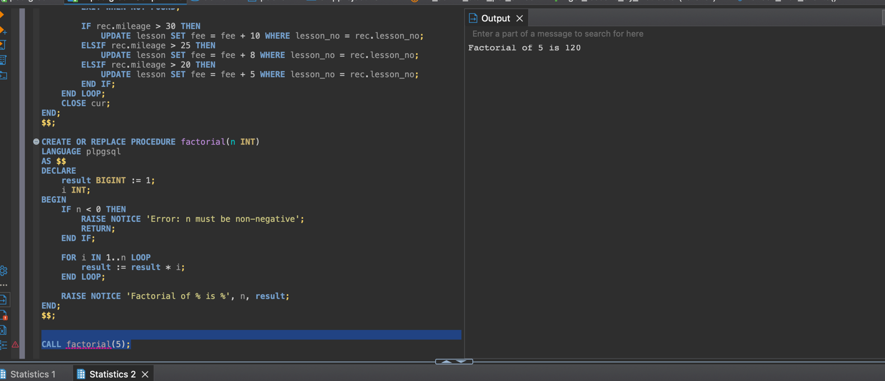
CREATE OR REPLACE PROCEDURE factorial(n INT)
LANGUAGE plpgsql
AS $$
DECLARE
result BIGINT := 1;
i INT;
BEGIN
IF n < 0 THEN
RAISE NOTICE 'Error: n must be non-negative';
RETURN;
END IF;

FOR i IN 1..n LOOP
result := result * i;
END LOOP;

RAISE NOTICE 'Factorial of % is %', n, result;
END;
$$;
CALL factorial(5);

Prepare tables SQL

CREATE TABLE office (
office_no VARCHAR(10) PRIMARY KEY,
o_address VARCHAR(100),
o_postcode VARCHAR(10),
o_tel_no VARCHAR(15),
o_fax_no VARCHAR(15)
);

CREATE TABLE staff (
staff_no VARCHAR(10) PRIMARY KEY,
f_name VARCHAR(50),
l_name VARCHAR(50),
s_address VARCHAR(100),
job_title VARCHAR(30),
salary DECIMAL(8,2),
nin VARCHAR(20),
sex CHAR(1),
dob DATE,
office_no VARCHAR(10),
CONSTRAINT fk_staff_office
FOREIGN KEY (office_no)
REFERENCES office(office_no)
);

CREATE TABLE vehicle (
veh_reg_no VARCHAR(15) PRIMARY KEY,
model VARCHAR(30),
make VARCHAR(30),
color VARCHAR(20),
capacity INT
);
CREATE TABLE client (
client_no VARCHAR(10) PRIMARY KEY,
c_address VARCHAR(100),
c_postcode VARCHAR(10),
c_tel_no VARCHAR(15),
d_license_no VARCHAR(20),
sex CHAR(1),
dob DATE
);

CREATE TABLE lesson (
lesson_no VARCHAR(10) PRIMARY KEY,
lesson_date DATE,
lesson_time TIME,
stage VARCHAR(20),
progress VARCHAR(50),
comments TEXT,
mileage_start INT,
mileage_finish INT,
staff_no VARCHAR(10),
client_no VARCHAR(10),
veh_reg_no VARCHAR(15),
CONSTRAINT fk_lesson_staff
FOREIGN KEY (staff_no)
REFERENCES staff(staff_no),
CONSTRAINT fk_lesson_client
FOREIGN KEY (client_no)
REFERENCES client(client_no),
CONSTRAINT fk_lesson_vehicle
FOREIGN KEY (veh_reg_no)
REFERENCES vehicle(veh_reg_no)
);
CREATE TABLE inspection (
inspection_id SERIAL PRIMARY KEY,
insp_date DATE,
insp_time TIME,
faults_found TEXT,
comments TEXT,
staff_no VARCHAR(10),
veh_reg_no VARCHAR(15),
CONSTRAINT fk_inspection_staff
FOREIGN KEY (staff_no)
REFERENCES staff(staff_no),
CONSTRAINT fk_inspection_vehicle
FOREIGN KEY (veh_reg_no)
REFERENCES vehicle(veh_reg_no)
);

CREATE TABLE interview (
interview_id SERIAL PRIMARY KEY,
i_date DATE,
i_time TIME,
i_room VARCHAR(20),
i_comments TEXT,
d_license_no VARCHAR(20),
staff_no VARCHAR(10),
client_no VARCHAR(10),
CONSTRAINT fk_interview_staff
FOREIGN KEY (staff_no)
REFERENCES staff(staff_no),
CONSTRAINT fk_interview_client
FOREIGN KEY (client_no)
REFERENCES client(client_no)
);
CREATE TABLE driving_test (
test_no VARCHAR(10) PRIMARY KEY,
test_date DATE,
test_time TIME,
test_centre VARCHAR(50),
tester_name VARCHAR(50),
attempt INT,
result VARCHAR(10),
p_test_comment TEXT,
t_test_comment TEXT,
client_no VARCHAR(10),
CONSTRAINT fk_test_client
FOREIGN KEY (client_no)
REFERENCES client(client_no)
);

